CORNELL NOTE REPETITION STRATEGIES

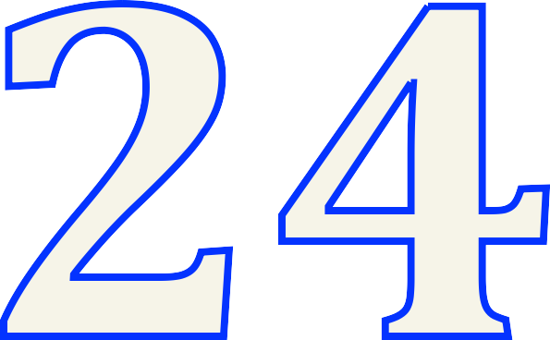
MINUTES -­‐ HOURS -­‐ DAYS

◊ Number Chunks
◊ Circle Key vocabulary
words
◊ Highlight main ideas
◊ Add missing information
◊ Paraphrase

◊ Write higher level questions
on the left

◊ Write a summary
◊ * Possible test questions
◊ Study notes

